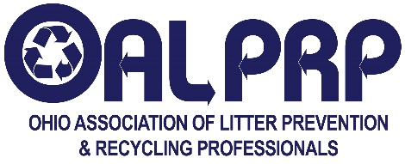
C. R. Meyers Scholarship Application
Entries must be e-mailed by noon or postmarked by April 15, 2022

Name: School:
Home Address:
School Address:
Principal/Dean: Counselor/Academic Advisor: __________
Home County: NOTE: You must be an Ohio resident to be eligible.
Email: ______________________________________________ Home Telephone:
Please answer the following questions. If additional space is needed, please attach additional pages.
To what colleges have you applied or are currently attending?

What college or university are you attending next year? (Only those attending an Ohio school are eligible to apply)

What is your anticipated major? (Only majors related to environmental studies are eligible to apply)

How did you find out about this scholarship?

What are your career goals?

Attach to this form:
- A one-page essay of approximately 500 words, describing your attitude toward and involvement in litter prevention, recycling, and environmental stewardship.
- A resume of your school and community involvement, emphasizing your environmental stewardship activities.
- A letter of recommendation from your guidance counselor or academic advisor that includes your current GPA.

Signature of Applicant: ___________________________________________ ________Date:

Signature of Parent or Guardian (If under 18): Date:

To email application, send to jjerek@mahoningcountyoh.gov. The author of the recommendation letter should send it separately to the same address. Emailed documents must be in Microsoft Word or PDF formats.

If using postal mail, send complete application to: C.R. Meyers Scholarship, c/o Jim Jerek, Mahoning County Solid Waste Management District, 345 Oak Hill Avenue, Youngstown, Ohio 44502

For more information, visit us at www.oalprp.org

